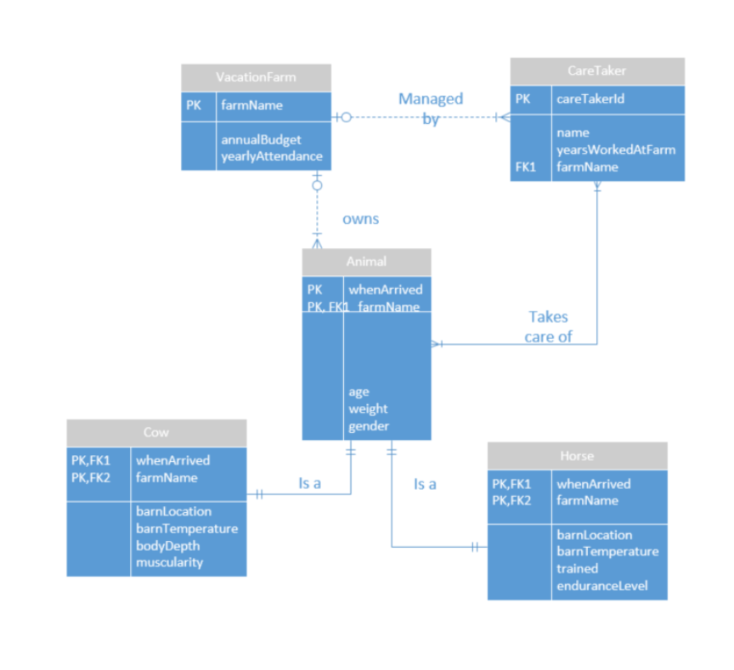
Farm
- Normalize:
- FKs seem to be in order
- Many to many CareTaker to Animal:
CaresFor(CareTakerID(fk), whenArrived(fk), farmName(fk))
- For each entity
- VacationFarm(farmName,annualBudget, yearlyAttendance)
- CareTaker(careTakerID, firstName, lastName, yearsWorkedAtFarm, farmName)
- Animal(whenArrived, farmName, age, weight, gender)
- Cow(whenArrived, farmName, barnLocation, barnTemperature, bodyDepth, muscularity)
- Horse(whenArrived, farmName, barnLocation, barnTemperature, trained, enduranceLevel)
- CaresFor(CareTakerID(fk), whenArrived(fk), farmName(fk))

- For each relationship:
- “managed by”
CareTaker(careTakerID, firstName, lastName, yearsWorkedAtFarm, farmName(fk))
- Constraints:
CareTaker(farmName(fk)) references VacationFarm(farmName)
- “owns”
- Animal(whenArrived, farmName(fk), age, weight, gender)
Constraints:
- Animal(farmName(fk)) references VacationFarm(farmName)

- “is a”
Cow(whenArrived(fk), farmName(fk), barnLocation, barnTemperature, bodyDepth, muscularity)
Constraints:
- Cow(whenArrived, farmName(fk)) references Animal(whenArrived, farmName)
- “is a”
- Horse(whenArrived(fk), farmName(fk), barnLocation, barnTemperature, trained, enduranceLevel)
Constraints:
- Horse(whenArrived, farmName(fk)) references Animal(whenArrived, farmName)
- “takes care of”
CaresFor(CareTakerID(fk), whenArrived(fk), farmName(fk))
Constraints:
- CaresFor(careTakerID(fk)) references CareTaker(careTakerID)
- CaresFor(whenArrived, farmName (fk)) references Animal(whenArrived, farmName)
- Final Schema:

- Animal(animalID, whenArrived, farmName, age, weight, gender, barnLocation, barnTemperature)
- Cow(animalID(fk), bodyDepth, muscularity)
- Constraints:
- Cow(animalID(fk)) references Animal(animalID)
- Horse(animalID(fk), trained, enduranceLevel)
- Constraints:
- Horse(animalID(fk)) references Animal(animalID)
- CaresFor(CareTakerID(fk), whenArrived(fk), farmName(fk))
- Constraints:
- CaresFor(careTakerID(fk)) references CareTaker(careTakerID)
- CaresFor(whenArrived, farmName (fk)) references Animal(whenArrived, farmName)
- CareTaker(careTakerID, firstName, lastName, yearsWorkedAtFarm, farmName(fk))
- Constraints:
- CareTaker(farmName(fk)) references VacationFarm(farmName)
- VacationFarm(farmName,annualBudget, yearlyAttendance)

